How to enter LEE Data in 4 Steps:

- Log into texas.nibrs.com

- Click the “LE Employee Data” button on the left-hand side menu.

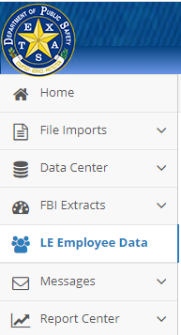

- Previous years LEE data will show, as well as a green button to create a new entry for the current year. If there is not a green button, this means the current year has already been created. Find current year amongst LEE Data list, then click the blue arrow located on the far-right side to view page.





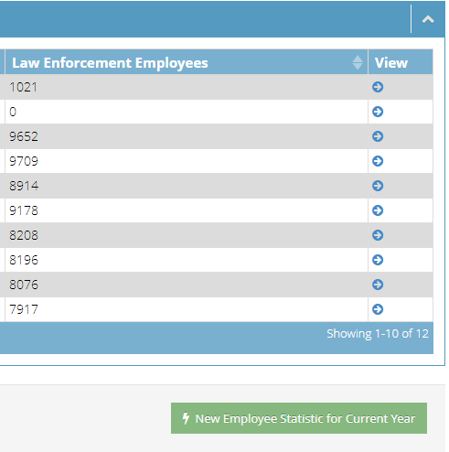

- Either choice will then bring up the LEE entry page:

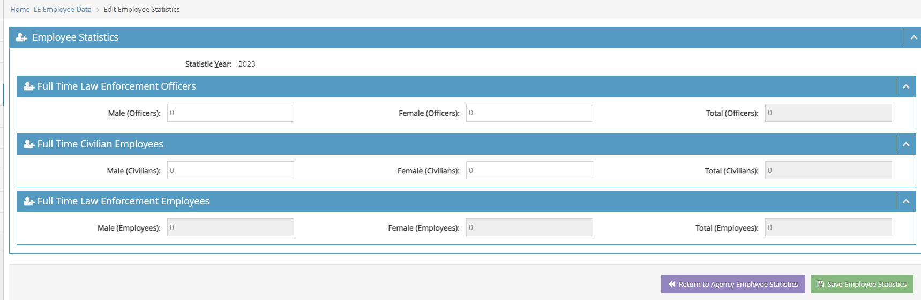

If you used the blue arrow to reach this page, this puts you in edit mode where you can update the LEE data and re-save it.

If you used the green “New Employee Statistic for Current Year” to get here, then you created a new “zero” report for your agency in our system. Not to worry, this is when you will enter your LEE data. Once you hit save, it will be added to our system.

